

Design Home Screen

Pemrograman Mobile II

**Home Screen**

1. Edit file **home_view.dart** yang ada di folder lib/app/modules/home/views, ubah code dari seperti ini

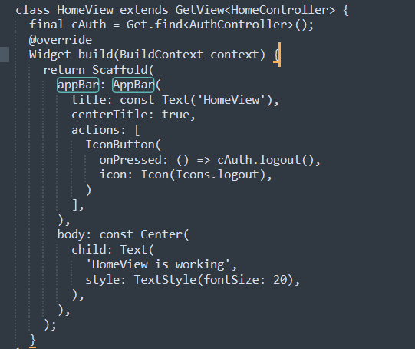

Menjadi seperti ini

class HomeView extends GetView<HomeController> {

final cAuth = Get.find<AuthController>();

@override

Widget build(BuildContext context) {

return DasboardAdmin();

}

}

1. Dibawah tutup kurawal terakhir ketik **stl**, lalu pilih yang statefull widget.
2. Beri nama DasboardAdmin
3. Tambahkan code berikut di bawah **_DasboardAdminState**

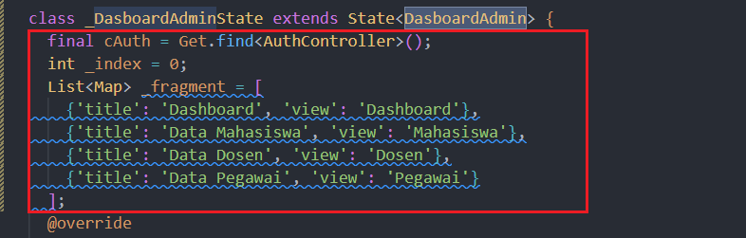

1. Dibawah code @override, Widget build dibuat seperti berikut :

Widget build(BuildContext context) {

return Scaffold(

drawer: drawer(),

appBar: AppBar(

backgroundColor: Colors.teal,

titleSpacing: 0,

title: Text(_fragment[_index]['title']),

),

// body: _fragment[_index]['view'],

);

}

Code yang akan jadi seperti ini.

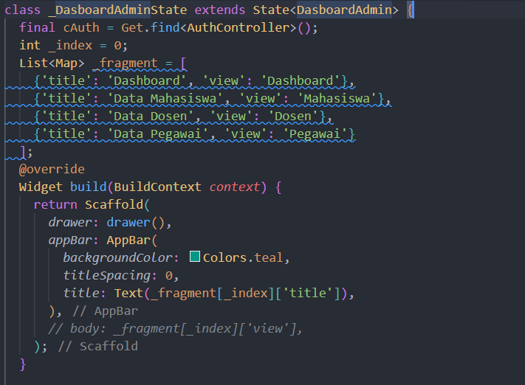

1. Tambahkan code setelah tutup kurung kurawal (}) Widget build, code nya sebagai berikut

Widget drawer() {

return Drawer(

child: ListView(

children: [

DrawerHeader(

decoration: BoxDecoration(

color: Colors.teal,

),

child: Column(

mainAxisAlignment: MainAxisAlignment.end,

crossAxisAlignment: CrossAxisAlignment.start,

children: [

Icon(

Icons.account_circle,

size: 80,

color: Colors.white,

),

Text(

"Reflan Nuari",

style: TextStyle(

fontSize: 18,

fontWeight: FontWeight.bold,

color: Colors.white),

),

SizedBox(

height: 2,

),

Text(

'Admin',

style: TextStyle(

fontSize: 12,

color: Colors.white,

),

),

],

)),

ListTile(

onTap: () {

setState(() => _index = 0);

Get.back();

},

leading: Icon(Icons.dashboard),

title: Text('Dashboard'),

trailing: Icon(Icons.navigate_next),

iconColor: Colors.teal,

textColor: Colors.teal,

),

ListTile(

onTap: () {

setState(() => _index = 1);

Get.back();

},

leading: Icon(Icons.people),

title: Text('Data Mahasiswa'),

trailing: Icon(Icons.navigate_next),

iconColor: Colors.teal,

textColor: Colors.teal,

),

ListTile(

onTap: () {

setState(() => _index = 2);

Get.back();

},

leading: Icon(Icons.people),

title: Text('Data Dosen'),

trailing: Icon(Icons.navigate_next),

iconColor: Colors.teal,

textColor: Colors.teal,

),

ListTile(

onTap: () {

setState(() => _index = 3);

Get.back();

},

leading: Icon(Icons.people),

title: Text('Data Pegawai'),

trailing: Icon(Icons.navigate_next),

iconColor: Colors.teal,

textColor: Colors.teal,

),

ListTile(

onTap: () {

Get.back();

cAuth.logout();

},

leading: Icon(Icons.logout),

title: Text('Logout'),

trailing: Icon(Icons.navigate_next),

iconColor: Colors.teal,

textColor: Colors.teal,

),

],

),

);

}

1. Tampilan akan menjadi seperti berikut.

